

Panther Parent Bulletin

Monday, January 20 – NO School

The 4K-6th grade phone is (608) 462-2600 ext. 2

**Report cards will be sent home with students on Tuesday, January 21**

January 8, 2025

Royall Elementary school

Royall Intermediate School



**4 Year-Old Registration for Fall**

# Thurs., March 6

**Call – 462-2600 ext 2 to schedule a time.**

If you have a child that will be 4 on or before

Sept. 1, 2025, you and your child are invited to participate in the Royall Elementary Child Development Day on Thursday, March 6 from

8:00 a.m. – 3:00 p.m. at Elroy Public Library. There will be informational booths, refreshments, and gifts. It will take approximately 1 hour. This is when you are enrolling your child for 4 year-old kindergarten. We look forward to meeting you. Please call 462-2600 option 2 to make an appointment.

**All incoming 4 year-olds must register.**

**Pennies for the Pantry**

The 100th Day of School is Thursday, February 6. Each student has been challenged to try and collect 100 pennies. The money will be donated to our local food pantry.

**Winter Programs**

The 4K – 6th grade students held a variety of Winter Programs in December. This featured classroom singers, boomwackers, a visit from the Grinch and 5th and 6th grade band.

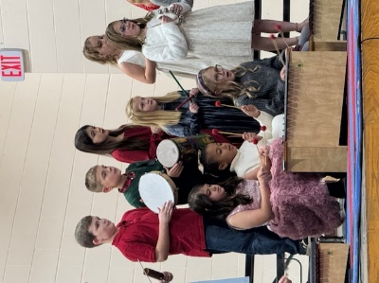****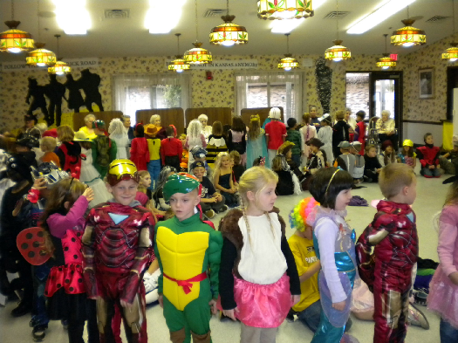 

**Panther 3-on-3 Tournament**

The Panther 3-on-3 Basketball Tournament will be held on March 29 for boys and girls in 4th – 8th grade at Royall Schools. Please pick up your entry form in the school office or by contacting Chris Brown at 608-853-2059, or by emailing Chris at:

christine100brown@gmail.com

**ENTRY DEADLINE IS MARCH 13.**

**Warm Clothing ~ Outdoor Recess**

The weather is beginning to change. It is important to have your child dressed for cold weather. The students go outside for recess everyday unless the temperature or wind chill is below 0 degrees, or it is raining. Students are encouraged to bring warm clothes to school including hat, mittens, snow pants and boots. All items should be marked with name or initials. If your child is in need of items, please call the school.

**Stepping Stones 4-H Vaccination Clinic**

On Saturday, January 11, there will be a rabies clinic at the Kendall Fire Station from 9:00 a.m. – 1:00 p.m. Rabies shots will be $25.00. Distemper, Lymes and Bordatella shots will also be available.

All Animals must be on a leash!

**School Closing Information**

The school will be using the Skylert System to notify parents of school delays or cancellations. School closing and delays will also be on the following radio and television stations between 6:15 a.m. and 7:30 a.m..

**Television Radio**

**Madison** Ch. 3 WCOW 97.1 FM

Ch. 27 WRJC 92.1 FM

1270 AM

**La Crosse** Ch. 8

Ch. 19

* **If there is a school closing or delay and you do not receive an automated message from the school, please let the school know.**

**Upcoming Events**

**Jan. 20 – No School for Students**

**(Teacher Inservice Day)**

**Friday, Feb. 14 – 2 Hour Early Release**

**Monday, Feb. 17 – No School**

Reminders

January 8, 2025

PLACE LOGO OR

COMPANY NAME HERE

PLACE PHOTO HERE,

OTHERWISE DELETE BOX

PLACE PHOTO HERE,

OTHERWISE DELETE BOX